FEEDING PASTORAL GOATS ON PASTURE
CAPRINEX 2015
BACKGROUND
World-wide there is very little information to draw on about pasture feeding goats in systems similar to those used in most of NZ for sheep and cattle. Overseas research, development and practices are with range feeding of low numbers, and pen-feeding that may include range. NZ goat research in the 1980s was abandoned after establishing some basic principles previously pioneered by farmers. However this tended to be based on the close management of high value goats that characterised the 80s and 90s. Commercial management now must fit into existing pastures and other stock in the best way possible to develop systems for the goats and farmer. This paper focuses on typical hill country farms and pastures.

BASIC PRINCIPLES
A basic principle for managing permanent pastures by grazing is to encourage desirable species and to discourage undesirable species, the definition of each being an individual farmer’s decision. The four components of that, adapted by the farmer to fit soils and climate to harvest most pasture while it is growing are
- The plant species themselves. The mixture influences total production but has different fertility needs, degrees of shade tolerance and reproductive state.
- The plant species age and stage in relation to the varying needs of the animals.
- The farm stocking rate reflecting intensification largely driven by economic factors.
- The method of grazing. For example hard spring grazing encourages clover for later stock finishing.
The main manipulation tool is the grazing animal itself, but it is sometimes difficult to compromise different plant and animal needs. The more complex the animal systems, the more difficult it is to plan.

NZ PASTURE GRAZING SYSTEMS
Up until about WWII, set-stocking was the common grazing management system. Dairy farms had a night paddock or two, and more day paddocks for a daily shift. Night paddock fertility increased at the expense of day paddocks that were not grazed properly or at the most nutritious stage, were weedy, and had low value rank feed smothering more desirable plants. On sheep farms, set stocking suited more territorial sheep, and gave better results because of less stress and better thrift. Thicker pastures withstood drought and pugging better.

However economic pressures for higher returns requiring higher stock numbers brought the need for more refined feeding for better pasture utilisation. As stocking rate increased, so did the % of pasture eaten, but putting on pressure from the Law of Diminishing returns. One way to reduce that threat is to replace some of the sheep/cattle with goats to utilise different feed better at higher animal production efficiency.

Rotational grazing developed to allow versatility in pasture management, but only with higher stocking rates at the level up to harvesting the maximum % of pasture without damaging its productivity or permanency.
2 The aim is to graze the pasture at its most nutritious, with grazing interval set by regrowth, and spelling to capitalise on surplus for later use. Pastures need to be high producing and NZ plant breeders have developed varieties and species specifically to perform under heavier stocked rotational grazing. This system is now generally used for NZ pasture/livestock farming in what has been described as orderly disorder to use paddocks in the best order to suit both.

One parameter is to try and have maximum pasture growth and quality, and root regrowth, by maximizing leaf area to capture light energy. The target is to have leaf area 5 times land area that it is growing on (15-20 cm high for mixed pasture). However quality starts to deteriorate from spelling longer than 3-4 weeks.

Rotational grazing does not necessarily grow more feed or increase clover which is the turbo feed for livestock production. The benefit is in controlling intake, reallocating surpluses and reducing losses in pasture volume and quality. It can also control sward characteristics that are more significant in hill pastures with their greater species mix and contour variations. However hill farms often have a mixture of rotational and set stocking.

MANAGING PASTORAL GOATS ON PASTURES
Goats can be included with fertiliser and fencing as essential pastoral production and management tools, especially on hill country.

Goats are fastidious eaters, seeking the best of what is available in their terms, and seeking dietary variety, which may be different to that sought by sheep and cattle that farmers are used to evaluating. Goats graze from the top down and are highly sensitive to pasture height in both set stocked and rotational systems. Intake necessary for production falls when mixed pasture is below about 10cms. They also walk a lot during a day’s feeding (up to 5km on hills) with consequent plant bruising and soiling making pasture unattractive. These eating behaviours do not suit typical mixed pastures found on most farms.

Top down grazing by goats alone encourages shade loving species like Yorkshire fog, and discourages higher producing species like ryegrass. There are three main options to cope
- Grow and feed special purpose plants that suit goat feeding like lucerne, prairie grass and chicory, or feed crops, but they are not as easy to manage, cost more to establish and maintain, and will not produce variety that goats need and prefer. They would need to be strip-grazed to maximize and maintain their production, and avoid goat trampling effects with a fresh daily break. This is an unlikely option on a hill farm.
- Rotationally grazed goats so that they are being fully fed on mixed pasture will often mean grazing ahead of other stock. They would necessarily be in one mob per rotation cycle and shifted frequently, perhaps daily. They would need to be part of a mixed livestock system where other animals are grazing pastures as required for maximum plant production.
- Let the goats range over as wide an area of mixed pasture as possibe to give them variety and to spread the trampling effect. As such they are skim topping pasture and eating pasture weeds to improve quality for other stock.

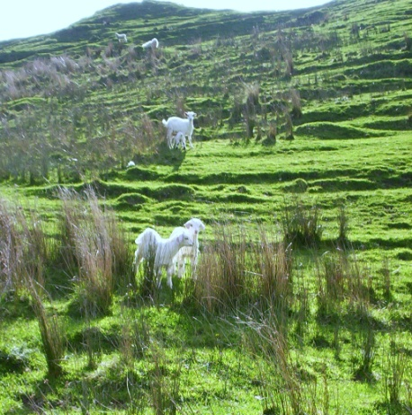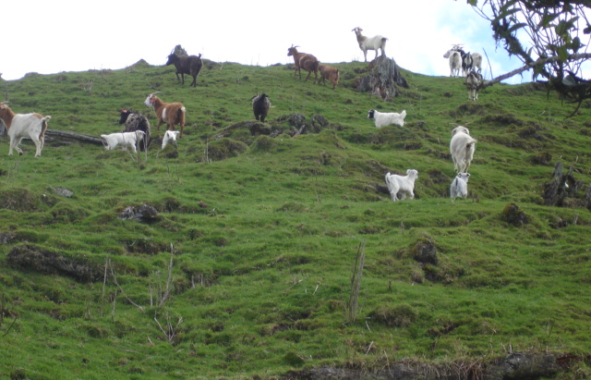

SPECIFIC POINTS RELEVANT TO GOATS FOR MAXIMUM GOAT NUTRITION
NB The following comments do not necessarily relate to weed control situations, especially of scrub weeds, where maximum goat nutrition is not necessarily the objective.

- The higher the pasture height, the greater the animal intake and therefore their production (applies to all grazing livestock)
- As a general rule, stock will do better under rotational grazing than set stocking because of more selective grazing opportunity, less competitive stress and better thrift. This is even more so with goats. They can either be shifted on purpose, or let roam to rotate themselves as they prefer to do anyway.
- Rotational grazing needs critical pasture height for maximum production from all livestock, is higher than for set stocking, so goats fit well into a rotational system for other stock.
- Pasture height is more important to goat feeding than pasture volume/density.
- Goats will stop grazing mixed pasture below about 1000kgs DM per ha. (about 2cm) but intake will have been gradually dropping from 10cm height.
- As goats are ranging widely on a pasture, feed requirements increase by 25% on easy country and 50% on steep country compared with pen feeding maintenance levels.
- As goats walk, they soil and bruise plants and make them less palatable.
- Once goats have defoliated 50% of the pasture species that they are eating, they should be moved.
- The internal parasite problem with goats is minimised with longer pastures that minimises egg uptake.
- An intake of 1kg DM per head day requires 6kg DM allowance (17% utilisation) and a pasture residual of about 2000kg DM per ha. (about 7cm)
- In a mixed pasture/scrub environment, goat intake will be about 50% pasture and probably not exceed 60%.
- Goat feed management considers pasture quality, physical intake limits, and animal needs that meet all farmer objectives. Intake other than pasture could have lower feed value, even if goats are eating it.

4
- As well as pasture height, green content is important for adequate quality. This is often from a clover base for other stock, but goats prefer not to eat clover in a mixed pasture if they have a choice; pasture assessment is different compared with for sheep and cattle.
- Maintenance requirement for a 36kg adult goat is 6 MJ ME per day. Lactation requires 5 MJ ME per litre with pastoral goat does producing up to 2 litres daily in the peak and a quarter of that after 3 months. Liveweight gain requires 3 MJ ME per 100gpd. Clearly, any production more than maintenance needs a lot of extra feeding.
- Grazing time during the day may be influenced by fluctuating soluble sugars and carbohydrate levels in plants, and greater fibrous intake later in the day for nighttime rumination.
- Obviously diet will be influenced by availability, but goats will deliberately seek variety.
- Goats need either time or training by their mothers to eat plants that are new to them.
In the end, remember that goats are opportunistic; eating the best that is available to them in their terms. That could be different to what sheep and cattle prefer.

