GOATS AND WEEDS CAPRINEX 2015
GENERAL COMMENTS
- Both the word GOAT and CONTROL have various meanings to different people, so generalisations can be dangerous. Before discussing weed control you need to define weeds species, the degree of control, time-lines and the type and size of goats.
- Goats can have a significant benefit over chemicals for weed control of many species with
- No health risks to people
- Fewer environmental risks on and off site
- Not depend on weather or contour
- No application cost
- Not oil dependent for chemical or application
- Optimal efficiency
- Better control timing is possible
- Effectiveness over time is better
- Goats will eat a wide range of weeds, 15 more plant species than sheep or cattle, with some being more palatable than others. However goats need to learn about any new species over time, or through parental teaching, to adjust their diet. Even less desirable and even poisonous species like ground tutu will be eaten when managed properly, and/or when in minor proportion to food available.
- As goats prefer dietary variety they will be eating a wide range of plants during daily feeding. If there are only a few plants of a specific weed in an area, they will be eaten more frequently than if there are lots of plants because the goats will be eating some of that plant daily. Consequently minor target weeds are reduced more rapidly.
- Goats are agile and have a mobile upper lip so they can eat through a range of plant horizons and access parts of plants unavailable to other stock
- Using goats to control weeds requires
- Acceptance that goats are not bulldozers or a chemical kill
- Necessary facilities, especially goat-proof fencing
- Goat management skills and knowledge
- Suitable goats
- Acceptance of the cost of pasture eaten as well
- Deciding on level of control and time available for the result you want
- Acceptance that results will not be spectacular in the short term
- Striking a balance between weed control objectives and goat performance and health
- The metabolic weight of a goat is less than the equivalent weight sheep if they are eating the same plants in the same quantities (which they are not in a weed control situation)

IT IS VERY DIFFICULT TO OPTIMISE WEED CONTROL AND MEAT PRODUCTION AT THE
SAME TIME.
IF WEED CONTROL IS THE OBJECTIVE, IT MUST TAKE PRIORITY
2 CONTROL OF SCRUB WEEDS
GENERAL
- Recommendations are based on area of solid weeds in a paddock, so you need to first assess the % cover of the target weed
- Normally goat diet is about 50% pasture where there is choice of enough weeds. That can be reduced to about 35% to increase scrub content. However as growth patterns of scrub and pasture are different, demands and supply over the year are different.
- Use goats in conjunction with other biological weed control organisms
- There is a direct relationship between goat numbers/stocking rate and degree of control. 250kgs goat LW per ha of solid weeds are needed to keep them in check. This can be increased up to 700kgs maximum. However gorse is a special case as it can also provide a lot of nutritious feed at certain times of the year.
- Management can use the goat’s ability to gain and lose weight through the year, especially of wethers that can lose up to one third LW in winter
- Wethers are the preferred animal for scrub weed control, and should have at least 2 teeth. They must be accustomed to the target species

MANUKA
- Goats will eat seedlings, and less than 25mm is preferred height for destruction
- Goats will ringbark older bushes, especially over winter
- Digestibility of Manuka leaves is less than 50% in spring
- Goats at a relatively low stocking rate of 200kgLW goats per ha of Manuka weeds will prevent reversion
- Goats dislike Kanuka

BLACKBERRY
- There are two techniques used for blackberry control, remembering that new shoots in spring are not preferred
- 300 kg goat LW per ha of solid blackberry weed will achieve positive reduction over 12 months
- 1500+kg goat LW per ha in autumn or over winter, will demolish bushes in weeks. Follow up with burn and oversow
- Goats can be set-stocked amongst set-stocked ewes at I goat per 2-3 ewes following this burn/sow programme. Rotational grazing is an alternative behind or ahead of ewes
- Goat numbers to maintain blackberry control will depend on infestation, but could be 2-3 per ha
- Low goat numbers through a paddock will maintain permanent control as blackberry is a preferred species
- Goats with fleece, especially Angoras, are in danger of being caught up in canes

3
RUSHES
- There is some goat preference for different rush species
- 300 kg goat LW per ha of rushes is needed to severely suppress rushes to half height to allow opening up for grass and clover to invade
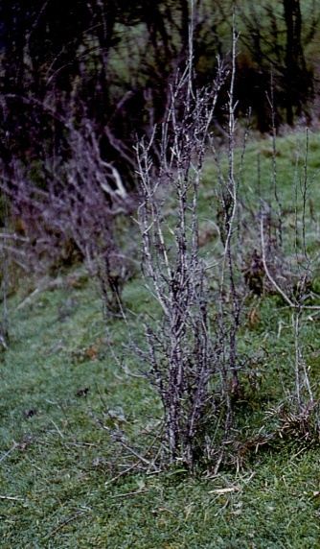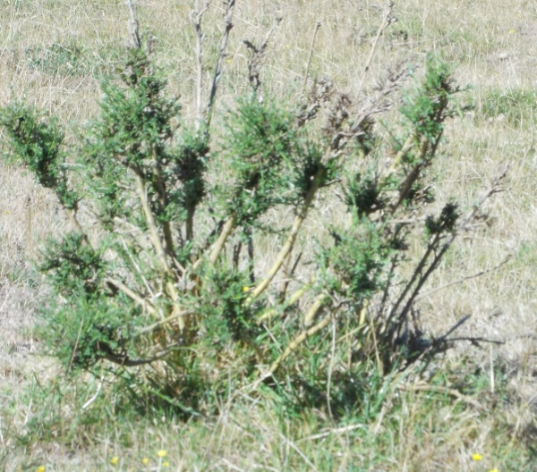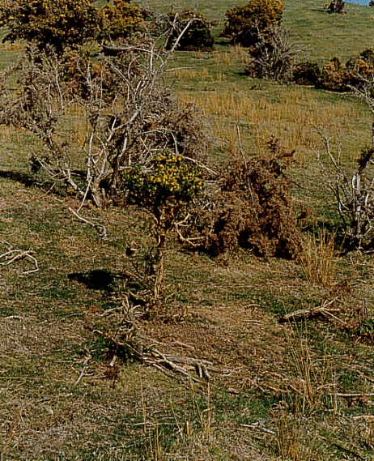
Manuka, Tauhinau and Gorse gradually being eliminated with biological control by goats

GORSE
Gorse control needs a different approach because of the residual seed problem. A prime objective must to not only eliminate the weed plant, but also to create a pasture to minimise seed regeneration.
FOOD VALUE
Gorse can grow strongly, requiring lots of goat mouths to control. At the same time it has value as a feed for them. Seedlings at 35 per sq.m density produce 11 000 kg DM per ha. Mature gorse can produce 15-25 000 kg DM, although not all would be eaten. Food value varies with age and maturity. DM % ranges downwards from 75% to 40% with age. MJ ME per kg DM range from 4-2. Spring digestibility is about 60%. Depending on locality and climate, most annual growth occurs between September and April with only 10% from May to September.
- In summary, adult goats could be getting 60% of their maintenance diet from gorse. However all the above factors need to be considered
- Taking into account gorse food value, control objectives can also be managed within the adult wether goat’s ability to gain and lose weight, with 50% difference between winter and summer matching gorse feed availability
CONTROL
There are different techniques for controlling standing gorse and regrowth. Given the challenge of eating the bulk of standing gorse, recommended first step is to reduce that by burning, or preferably crushing/rotting to start. That enables introduction of new pasture seeds and fertiliser, and the goat challenge is then limited to seedlings.
- With adequate goat numbers and competitive pasture growth it should be possible to achieve 90% + control of gorse within 4-5 years using this technique
4.
- After burning/crushing, 600 kg goat LW per ha of previous gorse area will be needed on regrowth in year one, increasing by 50% from year two, with later adjustment according to results.
- One example using 400kg goat LW per ha reported 75% reduction in gorse plants and 65% reduction in plant height by year two, and 90% and 82% respectively in year three.
- Goat and sheep combinations can work, but with internal parasite cross contamination. Goats and cattle combinations are better; cattle will not be damaging gorse seedlings as would sheep but longer pasture smothers seedlings better.
- Goats can be set-stocked, or rotated 1 week on/3 weeks off
- Goats will also ringbark older plants, especially in winter. A critical minimum height is about 1m – above which it is easier to attack from below. Plants that reach 1m as rounded pincushion bushes are difficult to kill at that point, although providing feed.
- Any goat control of mature gorse should incorporate other biological control measures.

BROOM
There has been less research on goats and broom control.
The above comments and recommendation for gorse can be applied to controlling broom, but need to recognise a different growth pattern, and that goats will not attack older plants to the same extent. Timing and stocking rates are more critical. Other biological and chemical assistance may be needed to overcome susceptible plants.

CONTROL OF PASTURE WEEDS
CALIFORNIAN THISTLES
- Californian thistles cost lost pasture production. At 10 stems per sq.m there was 600kg DM per ha lost under cattle grazing and double that under sheep grazing. At 13 stems per ha (30% ground cover) sheep weight gain was reduced by about 30% over a year.
- The control principle is to reduce overwintering shoot buds on roots in soil. Roots survive for 12 months and are replaced annually. They directly determine above-ground growth in following September – April. Goats can more effectively match other recommended techniques of repeated chemical applications, mowing – especially in rain, and hard grazing with sheep.
- Goats should be used to defoliate all shoots as low as possible 3X per season (Nov-Jan- March) for 2 and perhaps 3 years. If only one annual defoliation is possible – February is best timing, but will reduce the amount of control.
- A goat stocking rate of about 2000 kg LW per ha of thistles will be needed, and that will determine the area that can be treated in any one year.
- A noticeable effect will be increased plant density after the first year of goat eating as the thistle plants struggle to reproduce, so second and third year treatments are critical for success.
- Californian thistles are preferred over Nodding and Scotch thistles. They can also contain higher levels of Mn, Mg, Cu, Zn, Co, Se than mixed pasture.
- Scabby mouth could be a potential problem.

5
OTHER THISTLES
- Apart from Californian, there is some preference between other different thistle species, but is not of real importance in control programmes.
- A specific characteristic is that there are certain stages of growth when plants are not attractive, and others - especially at flowering stage, when they are readily eaten and by preference. Rosettes are rarely eaten, but plants are eaten from bolting stage in late spring/early summer. Flower heads are eaten first when green, and stems later.
- Thistle consumption is likely to be increased by having less pasture available to both improve access to the thistle plant itself and to reduce alternative feed.
- Seed heads are consumed but even mature seeds are unlikely to pass through the goat in a viable state. It is suggested that 150kg goat LW ha on hill country pasture with a typical thistle infestation will prevent seed production.
- Goat stocking rate recommendations are difficult as they depend on species, infestation levels, and paddock sizes. However experiences show that I goat per ha in 2-3 grazings will stop typical nodding thistle seeding, 400 kg goat LW per ha of variegated thistle was needed for elimination, and a mixed population of one third goats/two thirds sheep eliminated all thistles after several years.
- One nodding thistle per 10sq m reduced pasture production by 8% during Oct-May.

OTHER WEEDS
Goats will eat some other pasture weed species such as buttercup, ragwort, docks and even poisonous plants, but all need prior accustomisation and dietary choice including pasture.
Goats love docks, thistles at certain stages, ragwort, buttercup
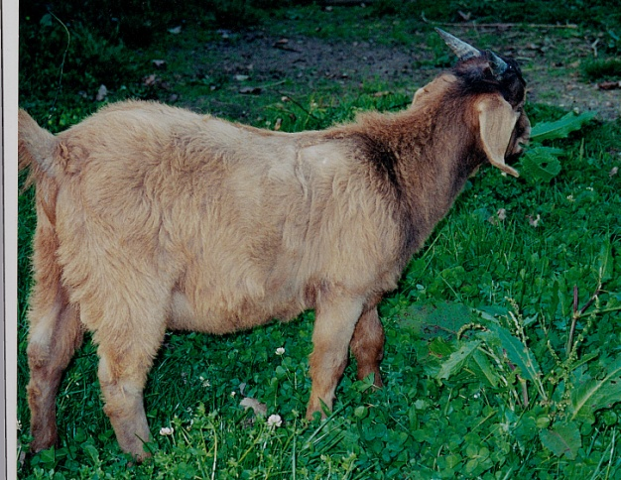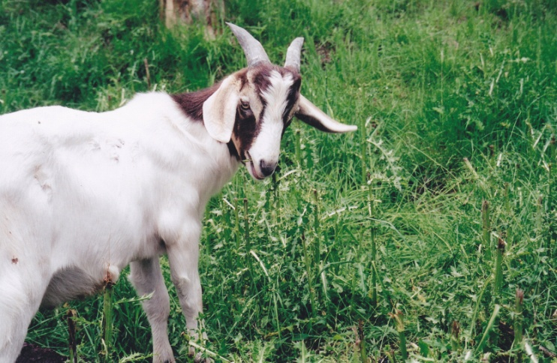

The same principles apply of % cover of weeds to pasture, time of year, stage of plants, numbers of goats. Goats will take some time – even months, to learn about new plants and whether they can eat them. They must not be introduced to weed plants, particularly poisonous ones when hungry, so either after a good feed or limited on/off feeding to start.

6

WEED CONTROL IN PINE TREES

Goats will eat pine needles more readily than other stock, so they can provide a feed source as well. This and their wide diet range weed eating abilities can be used for a specific role in controlling weeds in pine plantations.

- Goats can be introduced into a plantation at about 4 years of tree age as long as the growing tip is above goat eating height, and only in winter. The skirt of lower branches will initially keep the goats from damaging the trunk. They open up the forest for better growth and silvicultural access if needed as they nibble needles and trash surrounding weeds,
- As soon as all needles eaten and/or any trunk damage are seen, goats should be removed.
- At about 7 years of age, trees will be developing mature, tough, fissured bark that is resistant to ringbarking. This is another time for introducing goats, as they will again open up weed vegetation to enable silvicultural work, and will ringbark inferior trees for early thinning.
The key element to be planned and sorted first is how to manage the goats in a plantation to be able to ensure that they are all removed when required. Options to consider are:-
- Eliminate obvious trouble- makers
- Prior domestication is an obvious solution
- Familiarisation to the block at the start
- Regular mustering to maintain herd cohesion for later handling
- Training to hand-feeding signals and feed, coupled with established feed station areas
- Block fencing to strategic mustering/holding areas
- Open access to a specifically-built trap area around a water source, primed with permanent salt/mineral, with a non-return gate that can be shut at appropriate times and with ready access for goat removal when required
- Judas goats
- Wethers are preferable over females

The technique of using goats for weed control in pine plantations is obviously best suited to plantings in existing fenced pasture, utilising existing fences, where forest access roads established at the start are most likely to be on ridges where goats will draw up to when being mustered and that will provide good sites for yarded areas.

