THE KIKONUI ®

PROJECT
IMPROVING ON NEW ZEALAND PASTORAL GOAT GENETICS THROUGH IMPROVING THE KIKO MEAT GOAT

ARKO FARMS* 121 WIN VALLEY ROAD* DOVEDALE*
R.D 2 WAKEFIELD*TASMAN DISTRICT * NEW ZEALAND
Tel: 643 543 3605 <chregek@xtra.co.nz>

THE KIKONUI PROGRAMME 2015

HISTORY
KIKO MEAT GOATS
The Kikonui Project (Kikonui meaning better than Kiko) starts with the development of the Kiko breed in the early 1980’s at Brightwater, New Zealand. About 10,000 feral does from various North and South Island sources were screened to select 26 animals based on size, physical confirmation of feet, udder and mouth, temperament and general eye appraisal from which to start developing the Kiko breed. These does were mated to dairy breed bucks that were selected from commercial dairy goat herds based on the meat-type look of the dam and particularly good udder confirmation. Each year 6-10 dairy breed buck kids were obtained, hand reared and evaluated, from which one or two were selected for subsequent mating in the following year. After two or three generations of crossbred mating, the crossbreds were interbred. The basic philosophy of the Kiko breed has been to use population genetics of large numbers to identify superior animals performing in significant production areas. Consequently, selection was based mainly on growth rate and survivability. Lesser criteria were twinning ability of dams, and temperament. The programme used an open nucleus herd, breeding best to best, and independent culling levels.
By 1986 the Kiko programme was the basis of a paper at the Third International Goat Congress in Brazil, showing marked Kiko performance improvement of 70%+ over the base feral stock.
A limitation on the breeding programme had been the numbers of goats available constrained by property size. Six shareholders including three other farmers as Goatex Group Limited worked to expand the breeding herd. Eventually about 100 top does were selected from the shareholders combined 1000 does. This operation through the early 1980’s used the same principles of simple production selection parameters of growth rate and survivability and with more emphasis on twinning. Survivability basically focused on tolerance to internal parasites and lack of foot troubles, while being farmed under challenging environmental and nutritional conditions. The top buck kid in growth rate terms born in each generation was used to mate all does within the central flock in the following year.
From the early 1990s greater emphasis was based on survivability and, for example, the 30% of buck kids kept entire at marking were carried through for the following year and wintered on a heavy-soil block to primarily test potential foot problems. A very limited parasite control programme was practiced on the whole flock. Animals which did not handle the parasite challenge or the foot challenge were either culled or died. By this time it was possible to almost guarantee a 200% kidding.
During the operation of the original Kiko breeding programme and subsequent operations, goats were exported to tropical Western Samoa, Tonga, Papua New Guinea, Niue, Hawaii, and semen to Nepal. Animals in all exports were notably successful in acclimatising to this range of management and climatic situations. The crossbred animals in Nepal performed to a similar level to other crossbred animals in a research programme that had questionable parameters. Kiko goats also adapted well in New Zealand to a range of environments and climates.

AMERICAN HISTORY
In 1994, all the Kiko animals and records were sold to American interests represented by Goatex Group LLC. The new owners bought 60 does, a group of bucks and some young stock, took them to Canterbury, mated some and later exported breeding does to the United States plus some bucks. In the United States some animals were sold but the majority were super ovulated for an embryo transplant programme and numbers increased. The object of the USA import was to establish a new meat goat breed that would appeal to moneyed exotic animal collectors. This was partly successful with animals selling at exorbitant prices. The United States market at that time for those animals was not a meat goat market. It was an exotic animal market and is supported by a mentality that pays little regard to meat goat performance.
Twenty years later there were 3 Kiko Breed Societies, each driven by different philosophies. For example, one Breed Society would only accept registration of animals that relate directly back to the original New Zealand imported stock. The USA market is large enough to pay a premium for such animals and other “purebred” registered stock. One cannot criticise the breeding programmes of members of the society with this economic attraction. However prices and values may not bear any relationship to commercial meat values or productivity.
An example of the level of interest and application of the American exotic animal breeders is the fact that the American Kiko Goat Association paid US$40,000 for a Registry to enable it to establish a pedigree recording scheme, despite the fact that the four generations Registry was a figment of the US Goatex Group LLC’s imagination using only 1 year’s records.
Almost all the breed development in the United States has been pedigree based with emphasis on breed standards. Consequently there has been little emphasis on production characteristics There are exceptions, and the closed herd of Dr An Peischel of Goats Unlimited is one. Another is Lookout Point Ranch in Oregon continuing the low input, production-based philosophy that started the breed in NZ.
This USA pedigree-focussed activity that paid little attention to productivity or profitability was the stimulus to initiate the KIKONUI Project in New Zealand (see below) and capitalise on the established earlier experience with Kiko breed and use the same successful breeding philosophies and practices to realise the potential, and further develop a more productive and profitable pastoral goat.
Kiko photos on US breeder’s websites reflect developments in the last twenty years under different management and breeding decisions. Anyone can call a goat a Kiko, although entry on a Kiko registry might confer some extra status in USA. In New Zealand, Kiko goats from the original herd are incorporated into the KIKONUI Project, although Kikonui Xbreds could be called and registered as Kiko.

KIKO RESEARCH
Despite the focus on pedigree breeding and breed standards, the Kiko breed is sufficiently large in the United States to have generated some research interest. Tennessee State University has been conducting trials since 2003 comparing Boer and Kiko goats. (Boer meat goats are known through the world as being a well performed meat goat under certain conditions.) The results from these trials are summarized, and also full paper references are shown below. This research shows that USA Kiko goats, despite not being further selected for performance, are outperforming Boers under conditions of temperate, sub-tropical environments. A notable feature has been greater survivability and reduced feet and parasite problems, and survivability of kids to weaning. Later carcass analysis showed superior meat yield from Kiko and Kiko cross animals.
- “Reproductive and health traits among Boer, Kiko and Spanish meat goats under humid, subtropical pasture conditions …” R Browning et al J.Anim. Sci 2011 89, 648-660
- “Birth to weaning traits from a complete diallel of Boer, Kiko and Spanish meat goat breeds semi-intensively managed …” R Browning et al J Anim. Sci 2011 89, 2696-2707
- “Carcass yield traits from a complete diallel of Boer, Kiko and Spanish meat goat breeds…”
R Browning et al J Anim. Sci 2012 90, 709-722

performance to weaning 2004 and 2005 years combined TSU results

TRIAL CONDITIONS
- Tennessee State University Research Farm, Nashville, USA.
- 183m ASL - 36°17N 86°81W Rainfall: Annual: 1222mm 2004: 1434mm 2005: 1338mm
- Goats 1.5 – 5 years old. Stocked at 15 per ha on pasture plus hay and 464 gpd concentrate (160g CP/kg 69% TDN). Kids weaned at 3 months. Two routine drenches annually for internal parasites, plus extra drenches and hoof treatment for lameness as required.

- RESULTS
 | BOER |  | KIKO
Number of does | 61 |  | 51
Does kidding % | 81.1 |  | 95.2
Doe LW at kidding ± 1.0kg | 49.7 | ns | 48.4
Doe LW at weaning ± 1.0kg | 50.2 |  | 48.4
No of does kidding : no of does rearing a kid ± 3.8k% | 69.5 |  | 91.7
No of does weaning kids : no of does kidded ± 2.65% | 85.8 |  | 95.9
Annual doe survival rate % | 78.5 |  | 99.1
Born litter size (no of kids born) ± 0.07 | 1.85 | ns | 1.89
Born litter weight ± 0.22kg | 6.32 |  | 5.93
Weaned litter size (no of kids weaned) | 1.51 | ns | 1.69
Weaned litter size (no of kids per mated doe) | 1.03 |  | 1.54
Weaned litter weight kids per doe (kgs) | 26.5 |  | 30.2
Weaned litter weight kids per kg doe weight % | 53.5 |  | 64.3
Number of does experiencing lameness ± 5.35 | 78.3 |  | 40.1
Number of does with 2+ lameness incidents ± 4.75 | 53.5 |  | 12.7
Average number of cases of lameness per doe p.a. | 2.02 |  | 0.58
Mean FEC eggs/gm | 521.7 |  | 298.1
Does requiring extra drenching ± 4.1% | 43.2 |  | 9.8
Internal parasitism cases per doe p.a. | 0.54 |  | 0.10
Note: All differences are significant except where shown as “ns”. Preliminary results from 2006 year trial with same animals confirm the above.
KIKO COMPARED WITH BOER AS A MEAT GOAT FOR BREEDING – SUMMARY OF 6 YEARS
- Significant numbers of animals used
- Breeds compared using straightbred and interbreed crossbreds
- Weaning at 3 months
KIKO BOER
PROPORTION OF DOES WEANING AT LEAST 1 KID 84% 53%
LITTER SIZE AT WEANING 1.59 1.47
LITTER WEIGHT AT WEANING KGS 27.2 23.0
LITTER WEIGHT:DAM WEIGHT (WEANING) 62% 51%
ANNUAL RATES OF LAMENESS 32% 69%
ANNUAL RATE OF INTERNAL PARASITES 24% 53%
ANNUAL RATES OF DOE ATTRITION (loss from herd) 10% 28%
WHOLE HERD ANNUAL PRODUCTIVITY (kg weaned per doe) 22.0 11.7

“In conclusion, Boer does were less fit as expressed by relatively less health and reproductive merit than Kiko .. within the prevailing research variables. Kiko does appeared better suited for production as maternal lines on humid, sub-tropical pasture than Boer does. Caution is warranted when considering the infusion of Boer germplasm into doe breeding herds managed under wet climate pasture conditions when management inputs are provided at low to moderate levels.” Dr. Richard Browning Jnr.

CARCASS YIELD COMPARISONS
- 275 bucks 7 months old from complete diallel of Boer, Kiko and Spanish meat goats slaughtered
- Sire breed did not affect live, carcass and primal cut weights
- Kiko dams produced heavier live, carcass, primal cut weights and higher dressing % than Boer

KIKO CONCLUSIONS
It is clear from 6 years of research at Tennessee State University, under their conditions, that USA Kiko meat goats, primarily unselected for meat production characteristics, are superior to Boer meat goats for reproductive performance, kid performance to weaning and are therefore a superior maternal breed. Practical farmer experiences confirm that, plus their ability to perform to a high level under difficult environmental conditions affecting nutrition and management. Additionally, and perhaps surprisingly, Kiko meat goats also produced more meat. Their adaptability to a huge range of climatic and environmental conditions in USA and elsewhere in the world highlight the fact that the Boer goat breed reputation as the best meat goat in the world is misplaced.
HOWEVER it was also clear that a greater emphasis on productivity and profitability under challenging conditions could improve on these USA Kiko results that came from random selection of goats from a variety of herds where emphasis had not necessarily been on production. Consequently the Kikonui Project was established in 2003 in New Zealand to develop the KIKONUI® pastoral goat breed.
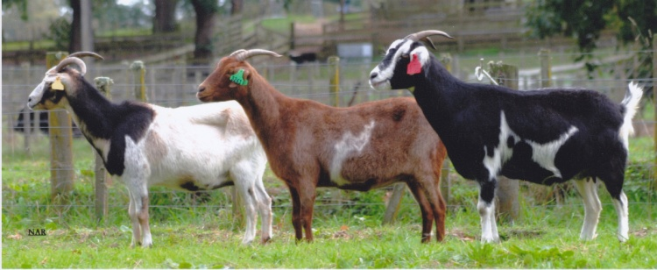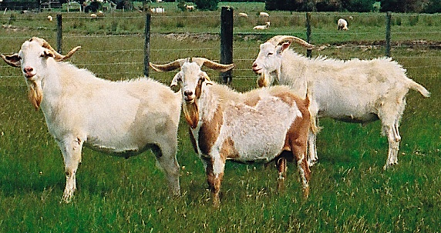
Base does and premier sires in 2003 at the start of the Kikonui® breeding Project

KIKONUI PROJECT

In 2003 it was resolved to reactivate the Kiko breeding programme, renaming it Kikonui (meaning better than Kiko) based on a central flock with satellite flocks to maximise numbers. The KIKONUI PROJECT bought back the remaining Kiko does in New Zealand that had not been exported to the United States which had been mated to either Kiko bucks or a Boer buck at some stage in the previous 10 years. This flock had been largely maintained as an entity. At the same time there was access to semen from premier sires Sesame, Sting, Samuel, and Shebang that had been not sold in 1994 and had been retained in New Zealand. Sesame and Sting were top ranked Kiko sires in 1984 and Samuel in 1983 and Shebang in 1982. This semen was used in the 2003 and 2004 Kikonui Project matings with a result that some kids born were sired by these sires. It was again used in 2008. Since 2005 and 2006, other bucks used in the central herd have been Kikonui bred bucks.

SATELLITE HERDS
An integral part of the KIKONUI PROJECT was a central herd of about 80 breeding does and up to nine variously sized North Island based satellite herds in different environments. Cooperating farmers were provided with bucks, in return for 5 top doe kids to the central herd for each buck used. In 2010 there were 9 bucks being used in satellite flocks. In addition there were also two share farmed herds mated to 5 Kikonui bucks (2010) where the Project had the opportunity to select doe kids for the central herd. For various individual reasons, by 2011-12 the satellite herds had been reduced to one and share-farmed herds to two as part of Project restructuring, but with an increase in the central breeding herd numbers.

BREEDING PHILOSOPHY AND SELECTION PARAMETERS
All doe kids born in the central herd and those selected from the satellite herds, apart from obvious culls and any single born, are carried through to 18 months old and evaluated at that stage for inclusion in the central herd. Suitable animals not selected go to share-farmed herds.
Only twin born buck kids are farmed through to 18 months of age although single born and obvious culls have been removed by that stage. Each year the top 30% weight gain, twin born buck kids are evaluated. The plan is to carry these bucks through to 2 years old for later evaluation with the intention of having them for sale to the industry. However sales can occur earlier.
As well as an emphasis on numbers and population dynamics and simple production selection parameters it is clearly obvious that early growth rate of young goats is a limiting factor in the industry. This is strongly correlated with a lack of milk from their dams, particularly at higher kidding percentages. Consequently the philosophy of using dairy breed blood has been continued from the earlier Kiko breeding to the Kikonui Project. In 2004, 2005 and 2006, dairy breed bucks have been used in satellite flocks. In 2004 and 2005 these were Toggenburg x Boer bucks and in 2006 these were Anglo Nubian bucks. This policy will continue at the lower levels of the breeding programme.
A feature of the selection programme is to challenge all stock with difficult nutritional and environmental conditions to identify those that will not perform under commercial low-input management. This can have severe effects on numbers and herd performance, especially in a spring such as 2010. In addition, the herd manger practices independent culling by eliminating any animal failing on any single selection factor. For example, a limping goat will be culled even if it is otherwise the best in the herd. Selection factors are not-twinning, feet problems, udder/teat faults, unmanageable behaviour, and parasite susceptibility. After such selection, priority is given to weight gain potential. Once the superior animals have been selected, the policy is to breed best to best, regardless of parentage. Significant production progress has been made since 2003 with adapting Kiko to Kikonui®.

PERFORMANCE
The central herd is under constant challenge so that performance can be adversely affected. This is reflected in reproductive rates and growth rates. The Project uses production efficiency as the main measure of performance, being the liveweight of kids at weaning (approx 110 days) as a percentage of dam liveweight at weaning. This reflects the main market parameters that operate in New Zealand, and income generated from capital and operating costs, especially feed. Obviously such an efficiency measure is directly related to kidding rates that have varied in recent years from 135 – 170%.
TOTAL CENTRAL HERD EFFICIENCY 2010 - 90%
2011 – 99%
2012 – 72% following severe conditions
2013 – 70% following mating mishap with later buck
However within the herd are superior animals. In 203-14 the top doe had an efficiency of 151% and 56% of the herd being twin-bearing does had an efficiency level of 96%.

It should be noted that all animals are fed solely on pasture, unhoused, and largely unshepherded. (However is should also be noted that they have in the past quickly adapted to more intensive management and pen feeding when being prepared for export and genetic material collection.)

Since 2008, significant breeding progress has been made with KIKONUI® in performance, if not in appearance. It will be apparent from the photographs that KIKONUI® goats can be heterozygous polled, and in a range of coat colours, as neither factor is considered as part of the selection process.

A major change occurred in 2015 when the Project assets were bought by ARKO FARMS LTD that had been a client for 6 years using Kikonui® bucks. This enables a simplified management structure with a base breeding herd expanded to about 400 does, many being Kikonui Xbreds, and will significantly improve the genetic improvement potential. They will be farmed on low fertility hill country incorporating scrub weed control, to continue the basic challenging conditions to highlight superior stock. Previous breeding policies, selection and evaluation will continue with more emphasis on the pastoral aspects and meat as an end product. (see www.kikonui.com and www.kikonui.sales)

THE KIKONUI PROJECT HAS NOW REACHED THE STAGE WHERE IT IS PRODUCING PASTORAL GOATS THAT ARE SUPERIOR TO KIKO GOATS, AND HAS CONTINUED TO DEVELOP ANIMALS THAT ARE ADAPTABLE TO WIDE RANGING ENVIRONMENTAL CONDITIONS TO MEET OBJECTIVES FOR PROFITABLE FARMING. THE PROJECT WILL BE CONTINUING WITH THE PROGRAMME TO ACHIEVE EVEN BETTER RESULTS.
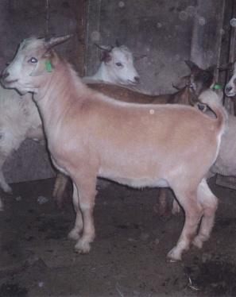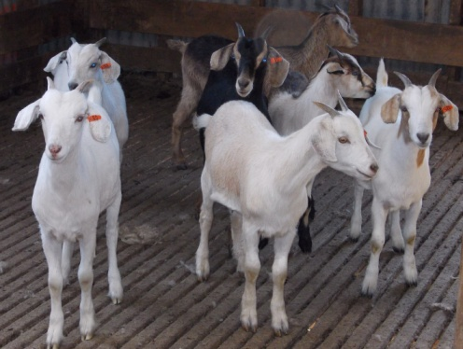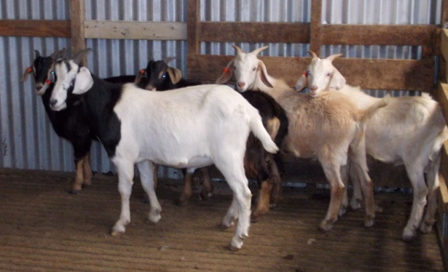
KIKONUI® 5 month kids after 10 years of development. Doe kids on left (2) and buck kids on right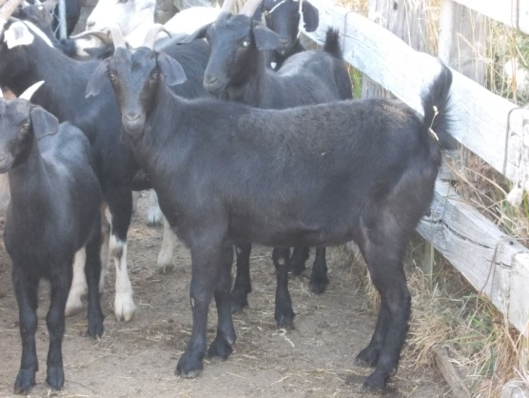 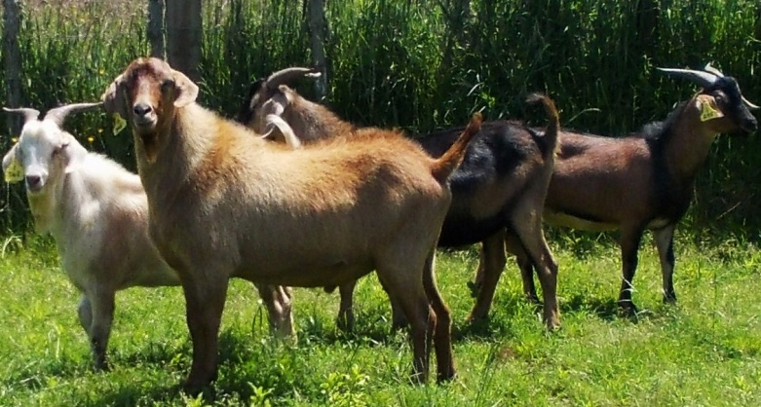
Young KIKONU® black does and multi-coloured bucks. 20 month buck in front - 2013 images

