NEW ZEALAND PASTORAL FARMING

New Zealand is a country of hills with only one –third having a slope less than 19 degrees suitable for wheeled machinery. Two –thirds of the land lies between 200 and 1000 metres ASL. Apart from limited drier areas on the east coast of both islands and Central Otago, it has a temperate climate, significant rainfall and snow in winter at higher farmed levels.

Most of the hill land has been developed from forest, brush weeds and tussock during the 20th century, with ongoing potential for reversion, and also from introduced weed species such as gorse and blackberry. It now is largely in permanent mixed species pastures based on nitrogen fixing, high protein clovers.

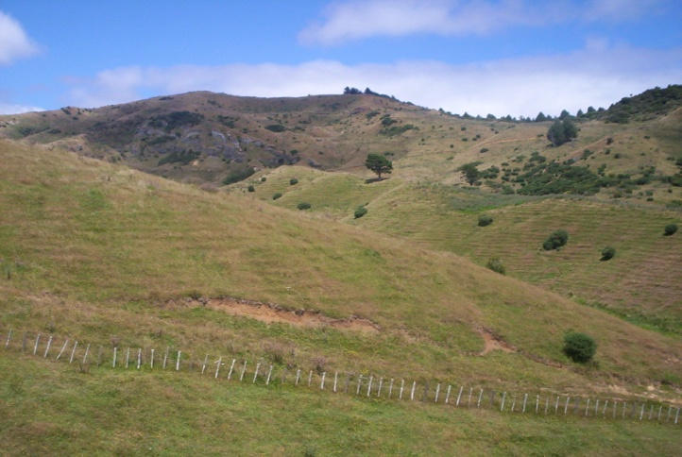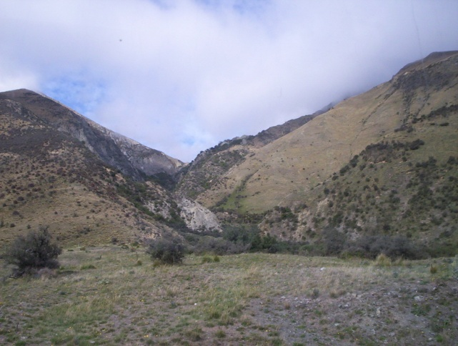

Apart from dairyfarming on easy contour areas farmed livestock on this land are predominantly sheep, cattle and deer. Animals are not housed, being grazed outside year-round on pastures, with limited supplementary feed.

Livestock meat and wool products from these hills are largely exported to markets with high access costs through freight and various tariff and non-tariff barriers. So farmers’ focus is on net profit as they are not subsidised. Consequently they have developed highly efficient systems to minimise labour, and to develop animals that suit these systems. Concurrently they seek ways to further minimise labour, feed and other operational costs to enhance profitability without necessarily increasing production per animal.
Pastoral goats are an essential part of the livestock mix to maximise profit on this country, just like fertiliser and fencing.

