NZ BIG BLOCK PASTORAL GOAT PRODUCTION SYSTEM
CAPRINEX © 2015

This Big Block Meat Goat Production system to suit specific situations is based on the fact that there is uneaten feed on a sheep or cattle farm that can be eaten by goats and turned into more money. That feed is coarse plants, pasture plants on banks between tracks, weeds including scrub, and pasture plants that sheep/cattle do not like. Goats will also eat the same pasture as sheep/cattle but as they are top-down grazers, they leave a clover base that has higher food value for sheep/cattle. So overall pasture quality is improved by 10-20% to compensate for what goats have eaten. The system works better with cattle because goats have the same worms as sheep, and because cattle pastures are better suited to goat grazing than pastures cropped by sheep.

It is deliberately simple. The maximum goat stocking rate is set by the plants that are there, how and when they grow, and therefore the time of least feed, and the principle that goats are eating feed that other stock aren’t. In every case it will be a very light rate and certainly no more than 10% goat liveweight of cattle liveweight per area. A possible ratio could be 1 goat per I cattle beast maximum.

This is not a weed control system. There is no attempt to positively reduce brush or other weeds. That would need a different approach.

Most profit comes from minimising infrastructure such as special goat fencing, yards and water, labour, management and animal health costs, and supplementary feed costs.

REQUIREMENTS
Goat proof boundary fencing is critical. The whole area being used could be subdivided into 2-3 not necessarily equal parts by goat-proof fencing to allow spelling and goat management if necessary. Or just one big area. Use electrified fencing, even just outriggers on standard fences.

A smaller specific goat-fenced kidding area with natural shelter, and artificial shelter such as tractor tyres and 15 inch culvert pipes is needed at kidding time, with creep access so that does only can wander and graze for the first couple of weeks of their kid’s life.

MANAGEMENT OF LAND
The goat flock is run as one extensive mob. How much management that is needed comes from type, age etc of the animals, and any market requirements for slaughter goats. The mob could be run over the whole of the goat-proof area which may be most of the whole farm with open gates where appropriate, or just a big part if there are goat-proof subdivisions. This is the complete opposite of normal rotational grazing that is being done with the other stock to grow more grass and manage them as they require.

A minimum sized goat proof-block should have 1 ha per adult goat. On typical hill country with a herd of say 200 does, this would mean 10-20 paddocks with at least 80% unstocked at most times and available for goats to range and feed in. Goats soon learn about gateways that helps with later mustering. Maximum block size could be the whole farm.

Although this is not a weed control system using goats, they will be eating weed feed, so weed growth patterns and feed value should be kept in mind. However at this stocking rate, there will be few times when there could be insufficient feed for goats needs.

2

MANAGEMENT OF GOATS
One likely system is for bucks to be out with does for 8 weeks. Once new born kids are a couple of weeks old they can open graze. The flock would be mustered when oldest kids were about 3-4 months old for male kid castration. No weaning. Further mustering is needed for culling and harvesting slaughter goats, and with health inputs as required. Young does left in the flock will be mated if they are mature enough, otherwise remain unmated but running with the flock.

Kidding date is a critical decision. You need to consider likely weather at kidding, feed supply for does rearing kids (remembering that pasture that they are eating should be above 10cms), and how good that summer feed is for weaned kids to grow on.

Depending on the size of the block, the whole herd may keep roughly together or split into sub-groups. Mating time will need observation. However the goats cannot be ignored at other times either, and in the course of other farm work opportunities should be taken to muster mobs to keep educating them, dogs and shepherds.

GOATS
Goats must be specifically trained to electric fences. A small training paddock that can also be used as the entry quarantine area for any new stock is important. Goats will also become quieter.This system requires a breed or type of goat that does not need routine feed or husbandry inputs, and that can look after itself. However this extensive grazing system means minimum stress, and minimum health and behavioural problems. Kikonui® pastoral goats are particularly suitable for this system because they have been developed under similar systems and conditions of low input, and feeding and management challenges to weed out non-performers.

Improving the herd comes from culling lower producers and replacing them with does bred within the system, and that have showed being able to perform at acceptable levels, and using superior bucks suitable to the system.

HEALTH
A quarantine process and treatment should be used with all new stock. Ongoing internal parasite control should not be necessary. However there could be specific local health problems that need prevention or specific treatments. Mineral needs can be different to other stock, so necessary supplements are essential to maximise animal health and production.

The philosophy is to accept minor losses of animal production and animals from health problems, as that cost will be less than preventative or curative treatments.

SUMMARY
This Big Block System adds a layer of pastoral goats to an existing sheep/cattle grazing system. With such a low goat stocking rate there is no real competition with other stock. As the goats can graze where they want to pick up the best feed available in their terms, they are not stressed so have few health or behavioural problems. That means not much stock work with them, but they cannot be ignored if they are to be profitable.
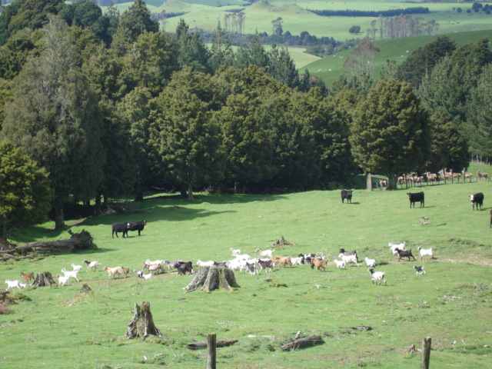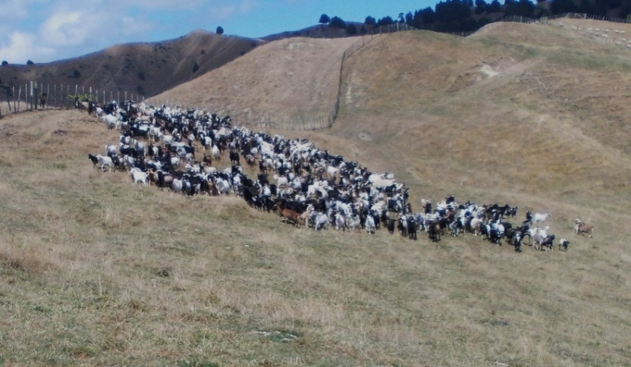
Goats spread out and mixed with cattle and/or deer will later mob up easily for handling

