THE PROBLEM WITH GOAT STOCK UNITS
©CAPRINEX 2015

SEVEN PROBLEMS - NOT ONE
1 The first problem is - what is a goat? If you were talking about a sheep or a breeding cow we would all have similar sized animals in mind, within a range. However an adult doe could be 25 - 70kg, and even within a more likely range, a 40kg animal is 50% bigger than a 27kg animal, both of which could well be in a typical hill country herd, and therefore eat 50% more on a liveweight basis. It could also be more efficient in production terms.

2 The second problem is the stock unit system itself. Warren Parker who used to be prominent at Massey University and later took over animal research management at AgResearch, produced an analytical paper to the Grassland Conference in 1998, noting how invalid were gross margins based on stock units, and the common fallacious beliefs based on such measures. This arose from the ad hoc and limited empirical data to develop standards, the wide range of performance levels within stock classes and the diversity between farmed species. There is even less for goats.

3 The late Alan McRae developed that further in a study commissioned for the Beef Council in 1999 that showed that over a year a breeding cow and her replacements used 4.72 times the amount of feed used by a ewe and her replacements for the given level of performance, but only 3.53 that level during the Spring. A standard 1 SU for cows was 573kgs DM whereas for a ewe it was 672kgs DM.

4 Then you get the variation in "standard" figures used by different authorities. For example, a ewe was calculated by Hutton AgResearch (1953/54) as 1.0, Coop (1965/67) as 0.8-1.1, B&LNZ Ec.Service 1.0, MAF 1.0, Lincoln University (1991) 0.65-1.45.

5 Then there is the variation in systems of production For example, according to McRae, 65kg ewes at 135% lambing need 672kg per SU wintered but 875kg per SU wintered to allow for replacements if they were run as well.

6 The stock unit system is a measure of pasture feed consumed. It takes all pasture as having the same values. It tends to assume a pasture quality level of 10.5 MJ ME per Kg DM. Goats can eat pasture at lower value levels and produce on that by eating more for the same level of performance. Goats could be eating less clover of higher food value anyway.

7 The stock unit system is based on NZ pastures. It does not recognise that goats have a wider dietary range that can include non-pasture. In particular it assumes that all animals are eating the same measured pasture when we know that goats on hill country are grazing between tracks on pasture not eaten by sheep for example.

(The 2009 GOAT Monitoring Project report used MWNZEcS standard of a goat being 0.8 SU, and clearly ignored the above factors for standardisation reasons i.e. an economist’s analysis rather than a management analysis).

Over the years the SU figure used for goats has varied from 0.3 (AgResearch- Ballantrae) to 1.0. Commonly 0.7 that reflects average body weight, has been used when goats are fully fed on sheep/cattle type pasture. However the variables are too great to use a standard figure.

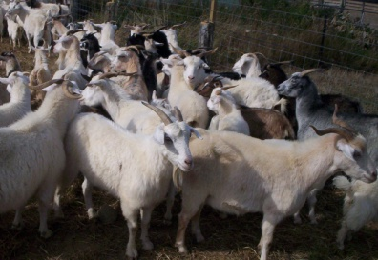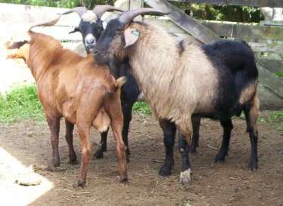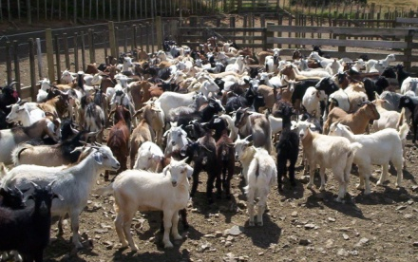

COMPARABLE PERFORMANCE

It is suggested that it would be better to compare goats with other stock classes on output performance terms rather than stock units, given the above limitations. For example -

Animal Efficiency

Taken as reproductive rate X progeny weaning weight
dam weight

USE YOUR OWN FIGURES IN THE FOLLOWING EXAMPLES
Breeding cows 80 x 220 90 x 220
500 = 34% 480 = 41%

Pastoral Goats 100 x 15 120 x 15 100 x 18
35 = 43% 35 = 51% 40 = 45%

Feed Conversion Income
Breeding Cows 7-8c kg DM

Pastoral Goats 13.-15 c per kg DM

(using 9MJ ME per kg DM pasture, I kg meat require 24.4 kg on Easy country (14.3c per kg DM)
25.2 on Medium (13.9 c per kg DM)
26.0 0n Steep (13.5 c per kg DM)

Another Approach to Income Generation

A 35 kg doe with 150% kidding to sale at 10kgs CW per kid requires 250kgs DM. This can be compared with a 60 kgs ewe at the same reproductive rate needing 715kg DM. ( Keeping in mind the reservations above about stock units)
This calculation shows that 1 kg goat meat @ $3.50 per kg CW requires 16.7 kgs DM OR 21c per kg DM income
A ewe producing say 25kg lamb requires 28.6 kgs DM per 1 kg meat @ $4.50 per kg generates $112.50 or 16c per kg DM income

